DAY-1
1.Reversing a 32-bit signed intergers:
#include <stdio.h>
int reversDigits(int num)
{
int rev_num = 0;
while (num != 0) {
rev_num = rev_num * 10 + num % 10;
num = num / 10;
}
return rev_num;
}
int main()
{
int num = 5896;
printf("Reverse of number is %d", reversDigits(num));
return 0;
}
OUTPUT:
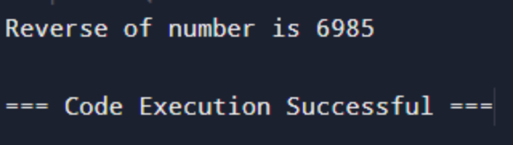
2.Vaild string no not:
#include <stdio.h>
#include <stdbool.h>
#define MAX_SIZE 100
int main() {
char stack[MAX_SIZE];
int top = -1;
char mapping[MAX_SIZE];
mapping[')'] = '(';
mapping[']'] = '[';
mapping['}'] = '{';
char *strings[] = {"((()))", "([{()}])", "(()", "([)]"};
for (int k = 0; k < sizeof(strings) / sizeof(strings[0]); k++) {
char *s = strings[k];
top = -1;
bool valid = true;
for (int i = 0; s[i] != '\0'; i++) {
if (s[i] == '(' || s[i] == '[' || s[i] == '{') {
stack[++top] = s[i];
} else if (s[i] == ')' || s[i] == ']' || s[i] == '}') {
if (top == -1 || stack[top] != mapping[s[i]]) {
valid = false;
break;
} else {
top--;
}
}
}
if (top != -1) valid = false;
printf("%s is %s\n", s, valid ? "valid" : "not valid");
}
return 0;
}
OUTPUT:
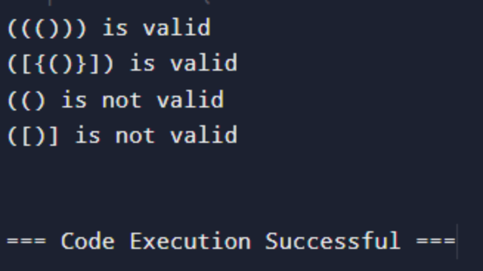
3.Merging two arrays:
#include <stdio.h>
int main(){
int arr1size = 5, arr2size = 5, arr_resultsize, i, j;
int a[5] = { 1, 2, 3, 4, 5 };
int b[5] = { 6, 7, 8, 9, 10 };
arr_resultsize = arr1size + arr2size;
int c[arr_resultsize];
for (i = 0; i < arr1size; i++) {
c[i] = a[i];
}
for (i = 0, j = arr1size;j < arr_resultsize && i < arr2size; i++, j++) {
c[j] = b[i];
}
printf("Merging of arrays is ");
for (i = 0; i < arr_resultsize; i++) {
printf("%d ", c[i]);
}
return 0;
}
OUTPUT:
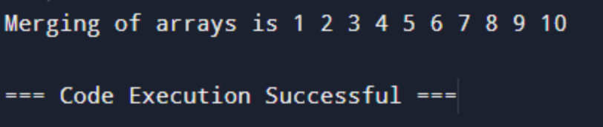
4.Array Finding Duplication Values:
#include <stdio.h>
int main()
{
int arr[] = {1, 2, 3, 4, 2, 7, 8, 8, 3};
int length = sizeof(arr)/sizeof(arr[0]);
printf("Duplicate elements in given array: ");
for(int i = 0; i < length; i++) {
for(int j = i + 1; j < length; j++) {
if(arr[i] == arr[j])
printf("%d ", arr[j]);
}
}
return 0;
}
OUTPUT:
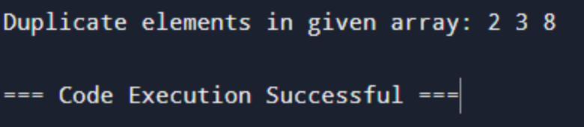
5.Merging of :
#include <stdio.h>
#define MAX_SIZE 100
void merge_arrays(int arr1[], int size1, int arr2[], int size2, int merged[]) {
int i, j, k;
for (i = 0; i < size1; i++) {
merged[i] = arr1[i];
}
for (j = 0, k = size1; j < size2; j++, k++) {
merged[k] = arr2[j];
}
}
int main() {
int arr1[] = {1, 2, 3};
int size1 = sizeof(arr1) / sizeof(arr1[0]);
int arr2[] = {4, 5, 6};
int size2 = sizeof(arr2) / sizeof(arr2[0]);
int merged[MAX_SIZE];
merge_arrays(arr1, size1, arr2, size2, merged);
printf("Merged list: ");
for (int i = 0; i < size1 + size2; i++) {
printf("%d ", merged[i]);
}
printf("\n");
return 0;
}
OUTPUT:
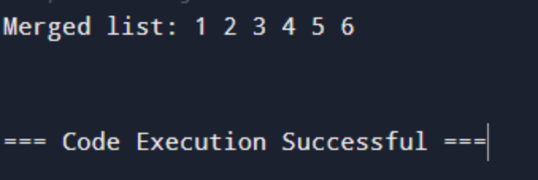
6.Registration Number Search:
#include <stdio.h>
#include <stdbool.h>
#define MAX_SIZE 100
bool search_registration_number(int reg_numbers[], int size, int target) {
for (int i = 0; i < size; i++) {
if (reg_numbers[i] == target) {
return true;
}
}
return false;
}
int main() {
int reg_numbers[MAX_SIZE] = {123, 456, 789, 1011, 1213, 1234};
int size = 6;
int target = 1234;
if (search_registration_number(reg_numbers, size, target)) {
printf("Registration number %d found!\n", target);
} else {
printf("Registration number %d not found.\n", target);
}
return 0;
}
OUTPUT:
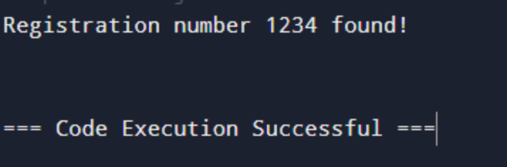
7.Identify location of Element:
#include <stdio.h>
#define MAX_SIZE 100
int find_element(int arr[], int size, int target) {
for (int i = 0; i < size; i++) {
if (arr[i] == target) {
return i;
}
}
return -1;
}
int main() {
int arr[MAX_SIZE] = {10, 20, 30, 40, 50};
int size = 5;
int target = 40;
int element = find_element(arr, size, target);
if (element!= -1) {
printf("Element %d found at element %d.\n", target,element);
} else {
printf("Element %d not found in the array.\n", target);
}
return 0;
}
OUTPUT:
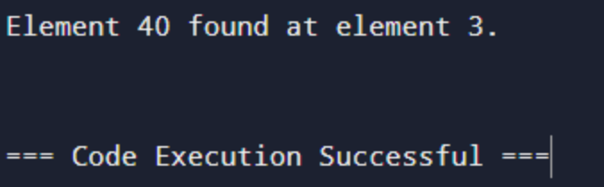
8.Array Odd and even Values:
#include <stdio.h>
void main()
{
int n;
printf("Enter number of elements in the array: ");
scanf("%d", &n);
int arr[n];
printf("Enter %d elements in the array: ",n);
for(int i=0;i<n;i++)
{
scanf("%d",&arr[i]);
}
printf("Even numbers in the array are: ");
for(int i=0;i<n;i++)
{
if(arr[i]%2==0)
printf("%d ", arr[i]);
}
printf("\n Odd numbers in the array are: ");
for(int i=0;i<n;i++)
{
if(arr[i]%2==1)
printf("%d ", arr[i]);
}
}
OUTPUT:
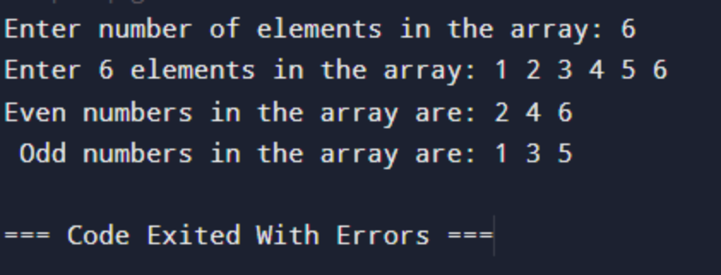
9.Sum of Fibonacci series:
#include <stdio.h>
unsigned long long fibonacci_sum(int n) {
if (n <= 0) {
return 0;
}
long sum = 0;
long a = 0, b = 1, temp;
for (int i = 1; i <= n; i++) {
sum += b;
temp = a + b;
a = b;
b = temp;
}
return sum;
}
int main() {
int n = 10;
long sum = fibonacci_sum(n);
printf("Sum of first %d Fibonacci numbers is: %lu\n", n, sum);
return 0;
}
OUTPUT:
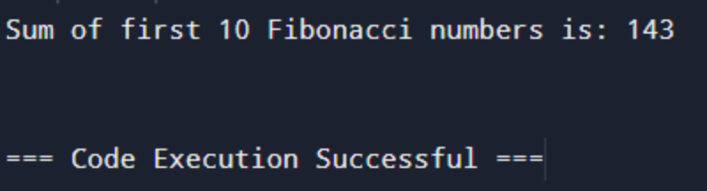
10.Factorial of a number:
#include <stdio.h>
int main() {
int n, i;
long fact = 1;
printf("Enter an integer: ");
scanf("%d", &n);
if (n < 0)
printf("Error! Factorial of a negative number doesn't exist.");
else {
for (i = 1; i <= n; ++i) {
fact *= i;
}
printf("Factorial of %d = %lu", n, fact);
}
return 0;
}
OUTPUT:
